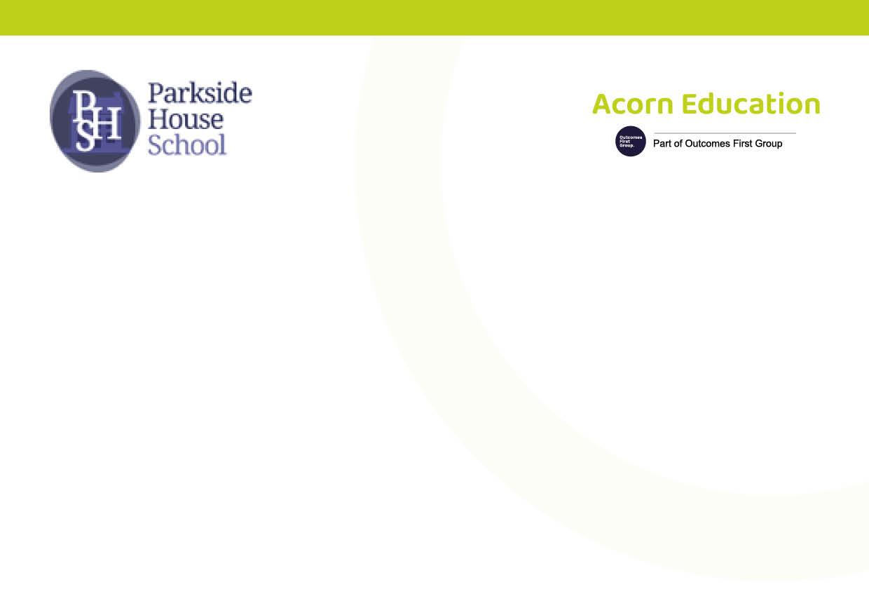
Parkside House School

School Prospectus

Date of last review | September 2026
Date of next review | September 2027

INTRODUCTION

Welcome to Parkside House School, an Independent Special School approved by the Department for Education for pupils with Special Educational Needs (SEN).

We are registered to accommodate up to 80 pupils, specialising in supporting those with Social, Emotional, and Mental Health (SEMH) needs, alongside other associated learning and cognitive difficulties, including Autism Spectrum Disorders, Attachment Disorders, Oppositional Defiance Disorder, ADHD, and ADD.

Our dedicated, experienced, and enthusiastic staff provide a curriculum tailored to meet our learners' diverse needs, helping them to become the best versions of themselves.

Parkside House School operates across two dedicated sites: one site is based in Backworth, North Tyneside and the other is based in Ashington, Northumberland. This dual-site arrangement allows us to provide tailored educational experiences that meet the diverse needs of our pupils. Each site is equipped with specialised resources and facilities, ensuring a nurturing environment where every pupil can thrive and reach their full potential.

GENERAL INFORMATION

Proprietor Representative/Chairperson:
Richard Power
Phone: 01204 522667
Email: info@ofgl.co.uk
Address: Acorn Education and Care, Atria, Spa Road, Bolton BL1 4AG

Chair of Governors:
Toni Woods
Email: Toni.woods@optionsautism.co.uk

Head Teacher:
Belinda Young
Phone: 0191 2161051
Email: belindayoung@parksidehouseschool.co.uk
Address: Parkside House School, Station Road, Backworth, Tyne & Wear NE27 0AB

Head of School (Backworth Site):
Alfie Wilkinson
Phone: 0191 216 1051
Email: Alfie.Wilkinon@parksidehouseschool.co.uk
Address: Parkside House School, Station Road, Backworth, Tyne & Wear NE27 0AB

Head of School (Ashington Site):
Gemma McCutcheon
Phone: 01670 85 22 44
Email: gemma@parksidehouseschool.co.uk
Address: Parkside House School, 8 Esther Court, Wansbeck Business Park, Ashington, Northumberland, NE63 8AP

MISSION STATEMENT - ETHOS AND VALUES

At Parkside House School, our mission is to provide a high-quality educational experience for pupils who face challenges in mainstream settings.

We focus on:

Developing fundamental cognitive skills.

Enhancing self-esteem and critical thinking.

Creating a safe, nurturing, and supportive environment.

We believe in fostering trust and respect among our pupils, which promotes positive responses and engagement. Our commitment to the needs of our pupils is paramount, and we work collaboratively with families, professionals, and stakeholders to ensure every pupil can thrive.

MEETING OUR MISSION STATEMENT

We believe our aims are best met through:

Experienced, subject-specialised staff committed to high-quality teaching and support.

Teaching National Curriculum subjects leading to accredited qualifications.

Encouraging participation in the local community.

Providing careers advice and structured vocational preparation.

Adapting the National Curriculum to ensure accessibility for all pupils.

PARKSIDE HOUSE SCHOOL AGREED AIMS

The agreed aims of Parkside House School include:

Actively developing parental partnerships for the benefit of the pupils.

Setting ambitious expectations for individual improvement.

Promoting a happy, healthy atmosphere of security, trust, and respect.

Fostering independence, self-advocacy, and informed decision-making.

Acknowledging and celebrating every pupil's achievements.

Maintaining high expectations for continuous improvement.

Involving all partners in the educational process.

ADMISSIONS POLICY

Applications for admission to Parkside House School are typically made by a SEND Officer from the local authority (LA) where the pupil resides. Parents have the right to express a preference for an independent special school approved by the Department for Education.

Pupils referred to Parkside House School will generally have a history of Emotional, Social, Behavioural, or associated learning difficulties, and will be aged between 11 to 19 years (Year 7 to Year 13). In exceptional circumstances, we may admit pupils early in Year 6 upon LA request.

REFERRAL PROCESS

For Parents/Carers

An informal request can be made directly to the school office via telephone or email, or through your local SEN department.

Each Local Authority has a Parent Partnership Service to support parents in choosing a suitable school.

For Local Authorities

An application must be made in writing by a SEND Officer, including relevant educational and behavioural information.

If the documentation indicates suitability and a place is available, we will invite parents/carers and the pupil to visit the school.

PARTNERSHIP WITH PARENTS

The role of parents/carers is crucial to the success of any school placement. Parkside House School encourages an open-door policy, with each pupil allocated a Pastoral Tutor to facilitate regular communication.

Communication Methods:

Weekly Reports: Each pupil receives a report every Friday.

Parents Evening: Held twice a year for progress discussions.

Yearly Progress Report: Comments on attainment and effort, with additional reports at Christmas and Easter.

Target Setting Meetings: Held at the beginning of the school year to set academic targets.

School Newsletter: Produced each term to highlight activities and achievements.

Form Tutors: Offer varying levels of contact with parents/carers, including daily feedback if required.

PARKSIDE HOUSE CURRICULUM OVERVIEW

Our curriculum aims to enable all pupils to become Successful Learners, Confident Individuals, and Responsible Citizens. It encompasses all planned learning experiences, both formal and informal, designed to promote intellectual, personal, social, physical, therapeutic, and cultural development.

Curriculum Goals:

Build on prior knowledge and aid long-term memory retention.

Ensure key components are embedded for complex task performance.

Provide opportunities for repeated recall to secure learning.

Contribute to overall subject goals and ensure optimal outcomes for all pupils.

Commitment to the National Curriculum

We are dedicated to covering the National Curriculum while aligning with each pupil's Education, Health, and Care Plan (EHCP).

EXPANDED VOCATIONAL OFFER FOR SEPTEMBER 2025

As part of our commitment to providing a comprehensive education that prepares pupils for future success, we are excited to share our expanded vocational offer for September 2025. This includes:

Hairdressing: A practical course designed to equip pupils with skills in hair styling, cutting, and salon management.

Catering: A culinary programme that teaches essential cooking skills, food safety, and nutrition, preparing pupils for careers in the hospitality industry.

Esports and Media: A unique opportunity for pupils to engage in the rapidly growing field of esports, including game design, streaming, and media production.

Skills for Employment, Training, and Personal Development: This programme focuses on essential life skills, job readiness, and personal growth, ensuring pupils are well-prepared for the workforce and independent living.

These vocational courses are designed to provide pupils with practical skills and experiences that will enhance their employability and personal development, aligning with our mission to support their transition into adulthood.

Pupil Entitlement

All pupils have the right to a high-quality education, regardless of ability, race, cultural background, or gender. We strive for breadth and balance, appropriate expectations, genuine challenge, and continuity in learning.

ADDRESSING SPECIAL EDUCATIONAL NEEDS

Upon admission, we gather comprehensive data to inform staff about each pupil's educational, social, and medical history. A full baseline assessment is conducted to set personalised targets for progress across the curriculum.

Curriculum Intent

Our ambitious curriculum aims to help pupils:

- Maintain positive and healthy relationships so they can socialise with others well and experience lifelong friendship and love. We know that this will help raise self-esteem and lead to a more positive outlook on life, thus helping to ensure the best future outcomes.

- Become emotionally resilient. Prior to joining us our children have found it difficult to understand and regulate their emotions, often leading to behaviour that has challenged. This has led to them being unsuccessful in previous educational placements. It is our ambition to support and educate our children, so they are able to regulate their emotions and behave in a way that allows them to be successful in the future. When children leave Parkside House school, we want them to understand their emotions and how best to manage them positively.

- Become tolerant and respectful individuals who will not undermine fundamental British values, including democracy, the rule of law and individual liberty.

- Achieve the best possible outcomes. We know that this is different for every child that attends our school. It is our ambition to ensure ALL learners develop detailed knowledge and skills across the academic, technical and vocational curriculum and therefore achieve the very best results. Careful baseline assessment of each child allows us to create differentiated provision with high expectations for every learner – the leadership team are unwavering in trying to help children secure their very best.

Curriculum Implementation

We offer a structured curriculum with a breadth of subjects leading to formal qualifications. Our delivery includes:

Academic Timetable: Clearly defined lessons with access to specialist staff.

Learner-Initiated and Adult-Led Teaching: Flexible teaching input in diverse sessions.

Thematic/Topic Learning: Integrated approach with cross-curricular opportunities.

Curriculum Offer | Curriculum Delivery
Academic | Academic Timetable
A breadth of subject offer leading to a wide range of formal qualifications. The National Curriculum will form a part of our whole school curriculum. We will take autonomy for our school curriculum and for the way we plan for and deliver the National Curriculum. | Structured and systematic approach with clearly defined lessons. Can follow a primary or secondary model of delivery. All have access to specialist staff and learning environments.
Learner-Initiated and Adult Led Teaching | A flexible approach with teaching input delivered in short and diverse sessions.
Thematic / Topic Learning | Integrated approach with cross-curricular opportunities around a focused theme or overarching question. Thematic learning space to support and enhance delivery.
Vocational | Training, development of skills and practical knowledge that may relate to occupation and employment.
Therapeutic | Individual and group interventions are offered and embedded across the curriculum with a structured, well-informed environment that supports pupils’ health and well-being.
Creative | Imaginative, problem-solving, and expressive in approach, practice, and originality.
Experiences & Talents | Providing new and rich opportunities for pupils to explore possibilities. Recognition and nurture of interests, ambitions, and talents. Opportunities to support and enrich.

The delivery of the curriculum is personalised, considering previous gaps in learning and the need to revisit key concepts. It has an emphasis on experiential and sensory learning across the curriculum. It references the National Curriculum and includes the following learning experiences:
• Linguistic (English): with an emphasis on communication integrated throughout the curriculum.
• Mathematical: Numeracy, with an emphasis on functional and experiential learning;
• Scientific: Biology, Chemistry and Physics; theoretical concepts and practical experiments;
• Technological: Digital Competence;
• Human and Social: PSHE/Citizenship, Geography, History and RE;
• Physical: P.E and Forest School;
• Aesthetic and Creative: Art, Music club, DT club/ Visits and opportunities (cultural capital)
• Therapeutic: sensory play, Enrichment Opportunities. Alongside the taught curriculum, pupils in all key stages engage in a range of experiences to develop their social and emotional skills.

On-Site Clinical Team Support

At Parkside House School, we understand that the emotional and mental well-being of our pupils is fundamental to their overall development and success. Our dedicated on-site clinical team comprises experienced professionals who provide tailored support to meet the unique needs of each pupil. This team works collaboratively with educators, families, and external agencies to create a nurturing environment where pupils can thrive. Through individual assessments, therapeutic interventions, and ongoing support, our clinical team helps pupils develop essential coping strategies, enhance their self-esteem, and improve their overall mental health. We believe that by addressing emotional and psychological barriers, we can empower our pupils to engage fully in their education and achieve their potential.

Key Stage | Curriculum Offer | Linguistic | Mathematical | Scientific | Technological | Human & Social | Physical & Aesthetic | Creative
Key Stage 2  Sunshine group | National Curriculum  English, Maths, Science, PSHE, RSHE, Humanities projects, Music, MFL theme days, Art, D&T, PE, Computing, Cookery | x | x | x | x | x | x | x
Key Stage 2  Sunshine group | Wider Curriculum  Team Building, (Forest School- summer term), Therapeutic Learning, Communication & Interaction, swimming, horse riding, animal care | x | x | x | x | x | x | x
Key Stage 3 | National Curriculum  English, Maths, Science, PSHE, RSHE, Humanities, MFL theme days, Art, D&T, PE, Computing, Music club, Citizenship. | x | x | x | x | x | x | x
Key Stage 3 | Functional Skills  ENTRY LEVEL- English, Maths, ICT  Wider Curriculum  Swimming, Cookery, DT, animal care, horse riding, additional enrichment activities i.e.- archery, (forest school-summer term) | x | x | x | x | x |  | x
Key Stages  4 & 5 | GCSE  English Language, Maths, Art, History, Geography, photography, ICT, Business Studies, Child Development | x | x |  | x | x | x | x
Key Stages  4 & 5 | Functional Skills  ELC, 1 and 2, English, Maths, ICT  Maths Award | x | x | x | x | x |  | x
Key Stages  4 & 5 | CTEC  Child Development | x | x | x | x | x | x | x
Key Stages  4 & 5 | ASDAN  Peer Mentoring- | x | x | x | x | x
Key Stages  4 & 5 | Wider Curriculum  PSHE, PE & Fitness, Careers, Advanced English, Additional Computing, Advanced Maths, , Duke of Edinburgh,  Boxing, Music, Mechanics, Football, | x | x | x | x | x | x | X
 | Fishing, Hair & Beauty
Options | Personal Development & Life Skills, Therapeutic Learning, D&T / Enterprise, Adventure Sports, Sports Leaders, Arts Award, Forest Schools, NICASS Rock Climbing, Mindfulness, Hair & Beauty, Sailing, Mechanics.  ASDAN Short Course: Cooking, Gardening & Horticulture | x | x | x | x | x | x | X
Enrichment and AP | Therapeutic Learning, Music, Mechanics, Football, D&T/Enterprise, Sport, Walking, Mindfulness, Farm Placements, Hair and Beauty, Barbery, Animal Care, Construction, Fishing | x | x | x | x | x | x | x

Sensory Integration

We recognise the sensory challenges pupils may face and adjust the curriculum to meet their sensory needs. Our focus on sensory integration allows pupils to thrive in a supportive learning environment.

VISUAL / AUDITORY / PROPRIOCEPTIVE / VESTIBULAR STIMULATION

To support our pupils' diverse sensory needs, we implement the following strategies:

Clearly displayed timetables (visual and interactive), which can be adjusted daily based on pupil needs.

Keywords/Topic vocabulary are clearly labelled, with areas and resources marked with expectations and objectives.

A range of resources are available for pupils to access and record across the curriculum.

Discreet displays are used in classroom environments to avoid visual overstimulation.

Emphasis is placed on stepped instructions, limited to no more than three steps or a more personalised approach to aid auditory processing and organisation.

We establish and prompt eye contact with the pupil before speaking to them, without requiring sustained eye contact.

Pupils are taught and supported to ask for help regularly, with staff constantly available for support throughout the school day.

Directions are broken down into small steps, allowing extra time for pupils to process them if needed.

Regular verbal prompts are used to increase alertness and refocus pupil attention on tasks.

We monitor and limit the time that focused auditory attention is required, considering classroom noise levels and using stimulation through music or visual/auditory clips.

Levelled questioning and instructions support pupils’ ability to access and respond.

Close attention is given to ensuring that a pupil’s education builds on previous learning. The greatest steps in learning occur when pupils can recognise connections between knowledge areas, so we actively seek opportunities for cross-curricular learning whenever possible. Staff teams maintain high levels of communication to help plan progression through the school.

The curriculum is structured to reflect Key Stages based broadly on chronological age, with flexibility to address individual levels of attainment. Teaching must match cognitive ability regardless of learning stage, and it is the teacher’s responsibility to ensure that all work is appropriately differentiated, allowing adequate time for consolidation of new skills learned.

Differentiation

Despite the relatively small class groups and high levels of learning support, there is a wide range of abilities within these groups. Pupils with complex learning needs and social, emotional, and mental health difficulties exhibit diverse preferred learning styles. Some thrive in small groups or pairs, while others prefer individual work; some excel in long-term projects, while others prefer defined tasks; some respond well to oral work, while others prefer written tasks.

To accommodate these differences, all staff at Parkside House School are responsible for planning work that meets the needs of all pupils. This involves adapting tasks, providing different resources, developing extension work, offering various learning styles and environments, setting individual goals, giving different levels of support, and allowing multiple ways to demonstrate knowledge and understanding. A thorough understanding of each learner’s EHCP needs, current curriculum progress, preferred learning styles, and Provision Map targets is crucial and documented in individual pupil profiles.

SOCIAL, MORAL, SPIRITUAL AND CULTURAL EDUCATION

At Parkside House School, we are committed to developing our students' Social, Moral, Spiritual, and Cultural Education. We ensure that partisan political views are not promoted in any subject, monitored through lesson visits and curriculum quality assurance. All curriculum areas contribute to pupils' spiritual, moral, social, and cultural development.

We respect and explore the integrity and spirituality of all faith backgrounds, recognising the diversity of spiritual traditions and providing access to alternative views. All adults model and promote expected behaviour, treating everyone as valuable individuals and showing respect for pupils and their families.

Pupils learn to differentiate between right and wrong, understanding the impact of their actions on others. They are encouraged to value themselves and others, understanding the need for rules and the importance of abiding by them for the good of everyone. The school code of conduct and classroom expectations reflect and promote character development, recognising progress and celebrating pupils' achievements. All curriculum areas aim to use illustrations and examples from a wide range of cultural contexts.

FUNDAMENTAL BRITISH VALUES

Parkside House School actively encourages pupils to respect the Fundamental British Values of democracy, the rule of law, individual liberty, and mutual respect and tolerance for those with different faiths and beliefs. These values underpin all teaching and learning and are explicitly taught through assemblies, PSHE, and pupils' active participation in the school council.

We aim to ensure that pupils have an understanding and knowledge of:

How citizens can influence decision-making through the democratic process.

The protection of individual citizens under the rule of law.

The accountability of bodies such as the police and the army to the people through democratic governance.

The legal protection of freedom to hold different faiths and beliefs, and the acceptance that differing beliefs should not lead to prejudicial or discriminatory behaviours.

The challenges of identifying and combating discrimination.

PROTECTED CHARACTERISTICS IN THE CURRICULUM

Protected characteristics, as defined by the Equality Act 2010, are specific aspects of a person's identity that are protected from discrimination. At Parkside House School, it is essential for all children to understand the diverse world they are growing up in and to learn how to live alongside and show respect for a variety of people.

All pupils are valued as individuals and supported to achieve their potential across all areas of the curriculum. We strive to help all pupils meet age-related expectations through carefully planned lessons that cater to their individual and special educational needs. Our curriculum remains as broad as possible for as long as possible.

We aim to reduce and eliminate inequalities and barriers that may exist. No child should be disadvantaged. Curriculum opportunities are planned to highlight positive role models who have overcome barriers to achieve success, celebrating pupils who have triumphed over challenges and recognising the achievements of individuals from diverse backgrounds, ages, ethnicities, and genders.

At Parkside House School, we foster positive attitudes and relationships both inside and outside the school. We actively engage with our community and work closely with parents and carers, inviting them into school regularly to share in learning experiences and celebrate achievements. We follow the principles of Safer Recruitment and uphold good equalities practises in staff recruitment, retention, and development, offering equal opportunities for all. Our staff are appointed without discrimination based on age, disability, gender reassignment, marriage and civil partnership, pregnancy and maternity, race, religion or belief, sex, or sexual orientation.

SUNSHINE CLASS

The Sunshine Class consists of a mixed-age group of Year 6 and secondary age Year 8 pupils. This group has been established to adapt to the individual needs of pupils exhibiting Social, Emotional, and Mental Health (SEMH) behaviours. The underlying philosophy is that these pupils often experience emotions and behaviours rooted in earlier developmental stages, which may be inappropriate for their chronological age. Additionally, noticeable gaps in cognitive development can impact their learning.

Characteristics of Sunshine Class Pupils:

Isolated and withdrawn from others.

Craving affection and forming indiscriminate, short-lived attachments.

Exhibiting pre-nursery behavioural features and immature dependent relationships.

Limited or under-developed play, language, and motor development.

Underdeveloped social relationships; difficulty sharing, resisting control, and displaying disruptive behaviour.

Problems with attention and concentration on age-appropriate activities.

In the Sunshine Class, students are taught with a high level of staff support. Pupils in this group present distinct behavioural and educational challenges, and much focus is placed on education through social interaction, play, and experiential learning, using personalised programmes of study. While they make progress in core subjects and enjoy thematically delivered studies, they learn essential social skills such as turn-taking, sharing, and formal and informal play.

The curriculum includes a wide range of visits to support their studies, as well as activities like storytelling, art, and crafts. Secondary age pupils from Year 7 are taught using a primary model, with a high level of personalised programming tailored to their specific interests and needs, which includes social interaction, problem-solving, and experiential learning.

Academically, there is a particular focus on core subjects, supported by a synthetic phonics programme for reading and a structured maths scheme offering personalised learning. Pupils participate in practical activities such as animal care, design technology, cookery, and sports. A key focus remains on developing their self-esteem and sense of personal well-being.

KS4 AND POST-16 LEARNERS

External accreditation is personalised to the interests, needs, and aptitudes of each individual pupil. Pupils at Key Stage 4 have access to a range of qualification pathways across core, foundation, and vocational subject areas. They are also starting a Duke of Edinburgh award at the Bronze level. Pupils joining us in Post-16 have the opportunity to revisit qualifications and enhance their outcomes from Key Stage 4 studies. Additionally, they can engage in courses at local colleges with staff support where appropriate. Alternative provision is monitored to ensure adherence to safeguarding and compliance.

Volunteering and work experience are key aspects of our Post-16 curriculum, and strong links are being formed with our local community to ensure pupils gain the experiences they need to progress in their chosen careers.

WORK EXPERIENCE, VOCATIONAL AND CAREERS GUIDANCE

Parkside House School endeavours to provide all pupils with a range of opportunities to participate in a workplace environment. Careers education and guidance are taught through timetabled Careers Lessons during form time and PSHE/Citizenship. All pupils have access to tailored and external guidance.

In Key Stages 3, 4, and 5, the emphasis is placed on the world of work, opportunity awareness, college experience, and work experience. All pupils aged 14 and over are provided with opportunities to engage in practice interviews and liaise with external guidance. This process also provides the specific information required to create individual transition plans. Pupils who are ready for work experience are supported with suitable placements guided through appropriate outside agencies.

Personalised learning is supported by Individual Personal Profiles to encourage pupils to pursue areas of interest and gain experience. Teachers, instructors, and learning support staff provide valuable support and guidance tailored to individual pupil needs. The aim of the school is for all pupils to leave with a suitable placement that matches their abilities and aspirations. We strive for all Year 11+ pupils to actively apply for sixth form, college, and apprenticeship placements

during their final year; however, for some pupils, it may be agreed for particular reasons that they remain at Parkside House School to complete Key Stage 5 with us.

For more information, please see our careers policy.

IMPACT

Curriculum Impact

Our School’s Curriculum will:

Fulfil all statutory requirements.

Be based on National Curriculum definitions of subject breadth and progression wherever possible.

Lead to qualifications that are useful for both employers and higher education.

Enable pupils to fulfil their potential.

Meet the needs of pupils of all abilities.

Be delivered in a supportive, therapeutic environment.

Provide equal access for all pupils to a full range of learning experiences beyond statutory guidelines.

Prepare pupils to make informed and appropriate choices at points of transition.

Help pupils develop lively, enquiring minds, an ability to question and argue rationally, and an ability to apply themselves to tasks and physical skills.

Include a range of vital characteristics: breadth, balance, relevance, differentiation, progression, continuity, and coherence.

Ensure continuity and progression within the school and between phases of education, increasing pupils’ choice during their school career.

Foster teaching styles that offer and encourage a variety of relevant learning opportunities.

Help pupils use language and number effectively.

Help pupils develop personal moral values, respect for religious values, and tolerance of other races, beliefs, and ways of life.

Help pupils understand the world in which they live.

Meet the social, emotional, and behavioural needs of our pupils.

Incorporate a specific curriculum for Key Stage 3 focusing on the core skills of numeracy and literacy while developing personal, learning, and thinking skills.

Incorporate a Key Stage 4 curriculum that meets the needs of pupils, parents, and wider society.

Offer a post-16 curriculum that is not constrained by the school curriculum alone but incorporates partnerships with other schools and colleges.

SCHOOL UNIFORM
Parkside House School has a School Uniform Policy which requires all pupils to wear the correct uniform. A detailed uniform list is available in the admissions pack.
We feel that wearing school uniform is important because, in a school with a wide social background, it masks trivial distinctions. A definite school identity can also be achieved from the wearing of uniform, which we believe is very important.

EXTRA-CURRICULAR ACTIVITIES
The school runs a number of Extra-Curricular Activities during lunchtime and after school, including:
- GCSE Booster Sessions
- Film Club
- Homework Club
- Science Club
- Hair & Beauty Club
- Art & Craft Club
- ICT Club
- Horticulture Club
- Warhammer Club
- Karaoke Club
- Music and Dance
- Cookery Club

SCHOOL COUNCIL
The school has an active and well-attended School Council that participates in the decision-making processes at school.

FORM TUTORS
Each pupil at Parkside House School has a Form Tutor, who is directly concerned with all aspects of the pupils’ welfare at school.
The Form Tutor completes weekly reports and prepares and attends all annual reviews of Special Educational Needs, LAC Reviews, and Care Team meetings with the SENCo.
When contacting the school to discuss your child, please direct all queries in the first instance to their Form Tutor.

DESTINATION ROUTES FOR PUPILS
Pupils leaving Parkside House School at the end of Year 11 or at the end of Year 13 will have several options for continuing their education, vocational placements, or employment.
Parkside House School is committed to providing our students with a programme of careers education, information, advice, and guidance (IAG) for all students in Years 10–11, which is impartial and effective. We also begin careers education via indirect working from Year 7. We aim to support the aspirations of our students and ensure that they gain the understanding, skills, and experience to make progress and succeed in learning and work.

Parkside House School endeavours to follow the Careers guidance and access for education and training providers (DfE, 2018) and other relevant guidance from QCA and Ofsted.
We have a dedicated member of staff for careers education and IAG. We provide pupils with the knowledge, information, and skills to make informed choices about suitable courses at school, college, and other providers. The service enables students to receive accurate information, advice, and guidance about the options available to them and the progression routes those options lead to.
Throughout Years 10, 11, 12, and 13, pupils can take up a 1 or 2-day work placement in various settings with alternative providers offering animal care, horticulture, painting and decorating, motor mechanics, ICT and computer repairs, and shop work. At Parkside House School, we encourage pupils, where appropriate, to take up a work placement to gain valuable experience and learn skills outside of the classroom, including social skills that will enable them to be functional in life after school.
Further education colleges that Parkside House pupils have moved on to include Newcastle College, Newcastle College Sixth Form, Ashington College, Gateshead College, and Kirkley Hall College. Pupils who do not wish to further their studies have taken up work-based placements at Newcastle Youth Action for Motor Mechanics, Resources for ICT, and The Army, to name a few.
Pupils who are leaving Parkside House School are supported and given the best advice to make the best choices for their future.

PROMOTING POSITIVE BEHAVIOUR
The school sees behaviour as a means of communication, and our philosophy for managing behaviour is as follows:
- We value developing strong and respectful relationships within the whole school community, including young people, staff, parents/carers, and the wider community, such as CYPS.
- We maintain clear boundaries and expectations to create safe and predictable environments.
- We regularly consult pupils to ensure their voices are heard.
- We recognise that children can be distressed and can experience meltdowns or shutdowns. We also acknowledge that some behaviours are just part of childhood and adolescence, such as pushing boundaries when developing independence.

- We understand that as a whole school community, we impact one another. Regular reflective practice enables us to understand, make sense of, and support this impact positively.
- Our philosophy is never based on punishment but focused on solutions. Our young people manage in the best way they know how, with the skills they currently possess.
- At times, children may become so distressed that additional measures are required to keep them and others safe. Our staff are trained to respond appropriately and must always use the least restrictive intervention possible.
- Our teachers and school team are role models in helping our pupils learn more skillful ways to experience success.
The school ethos is to nurture and praise, achieved by emphasising building good staff/pupil relationships. The school has a high ratio of experienced staff who recognise and reward good behaviour by using the positive reward system and trauma-informed practice approach.
- The Positive Reward System awards pupils’ credits and positive sleuths for participating in educational lessons and reaching their full potential, academically and socially. Credits can be traded in for activities half-termly.
The school employs a policy of non-restraint wherever possible, as we believe restraint is a negative strategy that can destroy self-esteem and harm relationships between staff and pupils. At Parkside House School, we prefer to build self-esteem and help our pupils feel good about themselves. Much of our pupils' success, academically and socially, is a product of the good relationships that develop between pupils and staff.

ABSENCE
If your child cannot attend school, please inform the school as soon as possible by telephone.

FIRE EMERGENCY
Fire and emergency evacuation procedures are practised regularly, and the assembly point is the school car park. Details of the emergency procedure are listed in every classroom.

ILLNESS & ACCIDENTS
We provide First Aid facilities in school, and pupils who become ill will be cared for until they can be collected or transported home. All accidents are dealt with by a qualified First Aider and recorded in the accident book.
It is essential that we have emergency contact telephone details for all parents or carers, and you will be asked periodically to complete updated emergency contact details for your child.

MEDICAL MATTERS
Parkside House School needs to know about any medical conditions that might affect a pupil’s wellbeing in school. Parents will be requested to complete a medical form upon acceptance of a place, which will be sent out yearly for updating.
To ensure the safety of all children, we do not store or administer medicine in school unless there is a direct and specific request from a doctor or Psychiatrist to do so.

HEALTH & SAFETY
The school has a comprehensive Health & Safety Policy, which is available in school and on the website for parents to read. Alternatively, a copy can be sent out if requested.
COMPLAINTS
This complaints procedure is required by law in paragraph 33 [Part 7 of the Independent School Standards], and the number of complaints registered under the formal procedure during the preceding school year will be made available on the school’s website.
The Difference Between a Concern and a Complaint
A ‘concern’ may be defined as ‘an expression of worry or doubt over an issue considered to be important for which reassurances are sought.’ A complaint may be generally defined as ‘an expression of dissatisfaction, however made, about actions taken or a lack of action.’
It is in everyone’s interest that complaints are resolved at the earliest possible stage. Many issues can be resolved informally (Stage 1), without needing to invoke formal procedures (Stages 2 & 3). We take all concerns seriously and will make every effort to resolve any matter raised as quickly as possible.

Who Can Make a Complaint?
Any person, including members of the public, may make a complaint about any provision of facilities or services provided unless separate statutory procedures apply (such as exclusions or admissions). The complaints procedure does not apply to prospective pupils who have no right of complaint.
Complaints from Parents/Carers
The procedures set out below relate only to complaints from parents of pupils, i.e., persons for whom education is being provided at the school. The process does not cover complaints from parents of pupils who have left (except in cases where the complaints process was started when the pupil was still being educated at the school).
It is expected that complaints are made as soon as possible after an incident arises (although three months is generally considered an acceptable time frame in which to lodge a complaint).
Informal Complaint (Stage 1)
If parents or carers have a complaint against the school, they may initially wish to contact the school informally either by telephone, in writing, or personally after making an appointment. The school will ask the complainant what they think might resolve the issue. The school will consider and resolve the complaint as quickly and efficiently as possible and will respond with the outcome within 10 working days of receiving the complaint. Where further investigations are necessary that may exceed this period, amended time limits will be communicated with an explanation for the delay.
Formal Complaint (Stage 2)
If parents or carers are not satisfied with the response at Stage 1, they should write formally to the Headteacher of the school (see end of document for contact details).
The Headteacher will investigate the complaint further and respond in writing within 10 working days of receiving the formal complaint in writing. Where further investigations are necessary that may exceed this period, amended times will be communicated with an explanation for the delay.
If the complaint is against the Headteacher, the complaint should be addressed to the Chair of Governors, also known as the ‘Regional Director’. Their contact details are at the end of the document. The Schools’ Chair of Governors will investigate and respond within 20 working days of receiving the formal written complaint.

Formal Complaint (Stage 3)
- If the parents or carers are not satisfied with the response from Stage 2, they should inform the School’s Chair of Governors, who will arrange a panel to hear the complaint.
- The panel will comprise three people not directly involved in the matters detailed in the complaint. At least one member of the panel will be independent of the running and management of the school. The member should not only be outside the school’s workforce but also should not be a member of the governing body/proprietorial body or otherwise involved with the management of the school.
- The date of the panel meeting will consider the availability of the parents or carers as well as the school and will take place within 30 working days of receiving formal notification that the complainant is unhappy with the outcome of the Stage 2 complaint and their desire to proceed to Stage 3.
- Parents or carers will be invited to bring with them another person or persons to support them at the panel hearing if they wish. The panel hearing does not confer a right on a parent to have a legal representative to make representations on their behalf at the hearing.
- The panel will hear the complaint and the outcome of the school’s investigations and its response to these. The panel will then make findings and recommendations, which will be communicated in writing within 10 working days of the conclusion of the hearing to the Proprietor, Director of Education, the Headteacher, the parent or carer, and, where appropriate, the person complained about.
- If a parent does not exercise the right to attend a panel hearing, the panel will meet in line with this policy. The school’s arrangements for the panel hearing will be reasonable to facilitate the parent(s) exercising the right of attendance.
- A written record of all complaints and their resolution, whether they proceeded to a panel hearing or not, will be kept on the school premises by the Headteacher (Equality Act 2010) and made available to the Proprietor and Ofsted inspectors on request. The school will record the progress of the complaint and the outcome. These records and any correspondence relating to a complaint will remain confidential, except where the Secretary of State or a body conducting an inspection under section 109 of the 2008 Education Act requests access to the records.
- The number of complaints registered under the formal procedure during the preceding school year will be published on the school website.

Complaints from Pupils
The procedures below will be followed in the event of a pupil making a complaint against a member of staff, a fellow pupil, or any other person or situation either in school or outside.
- Pupils may wish to talk to an adult they trust about a situation relating to school or outside school.
- Pupils are reminded that, although they may speak to any member of staff, there may be occasions where information will have to be referred to other agencies such as Children’s Services.
- Within school, pupils may talk to any member of Education Staff.
- A pupil may merely need a trusted adult to talk a situation through with and may not be making a formal complaint. However, all actual complaints made by pupils will be recorded by the member of staff in the Complaints Log. The school response to the complaint will also be recorded. If the complaint is serious, the pupil’s parents/carers will be informed of both the complaint and the outcome. Some complaints will be referred to other agencies or to the Local Authority. If necessary, a meeting will be called to discuss the issues further.
- A pupil may ask to speak to an adult from an outside agency. The school will, wherever possible, put the pupil in contact with a representative of the appropriate agency. The referral will be noted in the pupil’s file.
- If the complaint is an allegation against a member of staff, then the school’s safeguarding policy must be followed in addition to recording the complaint. Failure to follow this process may result in disciplinary action.
Unreasonable Complainants
The school is committed to dealing with all complaints fairly and impartially and to providing a high-quality service to those who complain. We will not normally limit the contact complainants have with the school. However, we do not expect our staff to tolerate unacceptable behaviour and will take action to protect staff from that behaviour, including that which is abusive, offensive, or threatening.
The school defines unreasonable complainants as ‘those who, because of the frequency or nature of their contacts with the school, hinder our consideration of their or other people’s complaints.’

A complaint may be regarded as unreasonable when the person making the complaint:
- Refuses to articulate their complaint or specify the grounds of a complaint or the outcomes sought by raising the complaint, despite offers of assistance.
- Refuses to cooperate with the complaints investigation process while still wishing their complaint to be resolved.
- Refuses to accept that certain issues are not within the scope of a complaints procedure.
- Insists on the complaint being dealt with in ways incompatible with the adopted complaints procedure or good practice.
- Introduces trivial or irrelevant information that the complainant expects to be considered and commented on or raises large numbers of detailed but unimportant questions and insists they are fully answered, often immediately and to their own timescales.
- Makes unjustified complaints about staff who are trying to deal with the issues and seeks to have them replaced.
- Changes the basis of the complaint as the investigation proceeds.
- Repeatedly makes the same complaint (despite previous investigations or responses concluding that the complaint is groundless or has been addressed).
- Refuses to accept the findings of the investigation into that complaint where the school’s complaint procedure has been fully and properly implemented and completed, including referral to the Department for Education.
- Seeks an unrealistic outcome.
- Makes excessive demands on school time by frequent, lengthy, complicated, and stressful contact with staff regarding the complaint in person, in writing, by email, and by telephone while the complaint is being dealt with.
A complaint may also be considered unreasonable if the person making the complaint does so either face-to-face, by telephone, or in writing or electronically:
- Maliciously
- Aggressively
- Using threats, intimidation, or violence
- Using abusive, offensive, or discriminatory language

- Knowing it to be false
- Using falsified information
- Publishing unacceptable information in various media such as social media websites and newspapers.
Complainants should limit the number of communications with a school while a complaint is being progressed. It is not helpful if repeated correspondence is sent (either by letter, phone, email, or text) as it could delay the outcome being reached.
Whenever possible, the Headteacher or Regional Director will discuss any concerns with the complainant informally before applying an ‘unreasonable’ evaluation.
If the behaviour continues, the Headteacher will write to the complainant explaining that their behaviour is unreasonable and asking them to change it. For complainants who excessively contact the school, causing a significant level of disruption, we may specify methods of communication and limit the number of contacts in a communication plan. This will usually be reviewed after six months.
In response to any serious incident of aggression or violence, the concerns and actions taken will be put in writing immediately, and the police will be informed. This may include banning an individual from the school.

STATEMENT ON QUALIFICATIONS ACHIEVED
We encourage pupils to sit GCSE exams in subjects we believe they can manage. Those we think cannot cope with English or Maths at GCSE level are entered for the Entry Level Certificate, Functional Skills, Unit Awards, or Vocational Qualifications.
We do not select the examination results we publish, as we believe that all our pupils’ efforts represent an achievement of which they and we can be proud. Please note, however, that due to our low year group sizes and the extent of the difficulties some of our pupils have, performance levels can vary widely from one year to another.

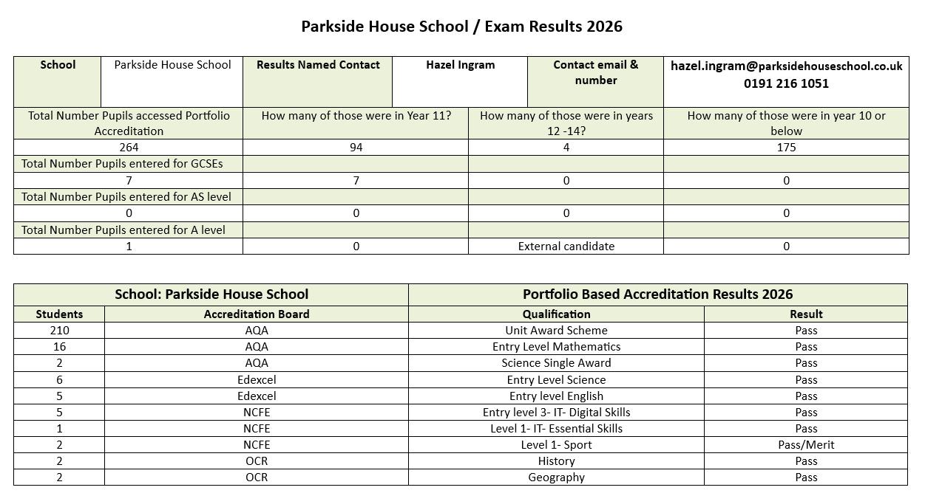

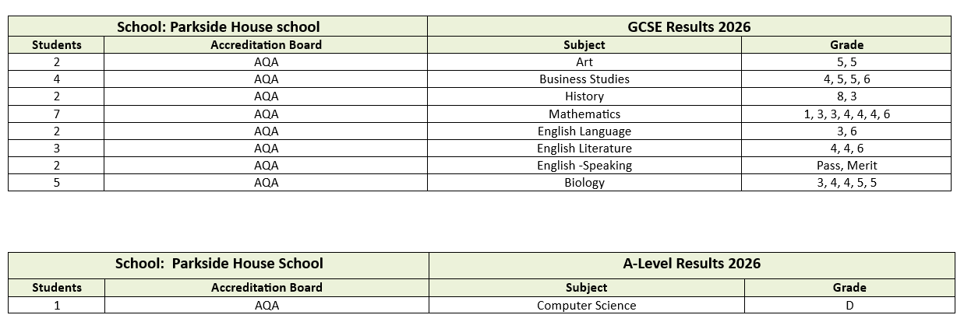

STAFF AT PARKSIDE HOUSE SCHOOL

Head Teacher | Mrs. B Young
Head Of School | Mr. A Wilkinson (Backworth site)  Ms. G. McCutcheon (Ashington site)
Deputy Head | Mrs. H Ingram
DSL | Mr. M Bradley
SENCo | Mrs. A Cowley
Clinical Lead  Therapy Assistant | Mark McGuigan  Alyssa Rannie
School Business Manager | Mrs. J. Lowery
Teaching Staff | Miss C Kaminski  Mr. R Mills  Miss. E Cook (Curriculum Lead)  Mr. P Dixon  Mr. J Turnbull (Behaviour and Attitudes Lead)  Miss. C Scott  Miss. C Goldsborough (Personal Development Lead)  Mrs. S Bhattacharyya  Mr. D Pearce  Mrs. J. Scott (Personal Development Lead)  Miss. A. Rattcliff  Mrs. L. Pankhurst  Ms. R. Kinghan  Miss. L Heaton  Mrs. J Unwin  Mr. A Davidson
Pastoral Staff | Miss D. Hewitt (Pastoral Manager)  Mr. M. Slee  Mrs. H. Armstrong  Miss J. Grey  Miss K. Ryan
Learning Support | Mrs. R Johnson (HLTA)  Mrs. N Begum  Mrs. H Low  Mr. R Hoole  Mrs. S. Swinburne  Mrs. C. Richardson  Mr. D. Manasse  Ms. C. Courtney  Ms. B. Lowery  Mrs. R. Carter  Ms. N. Rickerby  Ms. K. Johnson  Miss. K Chambers  Miss. P Iveson  Mrs. L Morgan  Miss. S Scott  Miss. O Sprudd  Miss. M Archer  Miss. L Marland
Administration | Mrs J. Bulman  Miss. A. Young  Miss S. Mowbray
School Cook | Mrs. T. McLean (Backworth site)  Ms. K. McSparron (Ashington site)
Kitchen Assistant | Mrs. N Chambers (Backworth site)  Mr. T. Todd (Ashington Site)
Facilities Supervisor  Facilities Assistant | Mr. S. Turnbull  Mr. P Rattcliff

The Governing Body of Parkside House School is:

Justine Sims- Regional Director & Chair- Safeguarding Governor- Justine.Sims@ofgl.uk
Toni Woods – Assistant Regional Director – Toni.Woods@optionsautism.co.uk
Belinda Young – Head Teacher - belindayoung@parksidehouseschool.co.uk
Sarah Makin - Sarah.makin@reddishhallschool.co.uk

