


Summer

2023-2024

Head Teacher Mrs Young End of Year Statement

As always, this school year seems to have passed by in a blur and again, we are here at the end of the school year. This is always a time of sadness and happiness combined. We are sad to say goodbye to our leavers who are moving on to pastures new, we wish them every success with their further education placements, but happy to reflect on all that we have achieved over the year.
I wanted to use this opportunity to say a massive thank you to our wonderful team who work incredibly hard to make PHS the nurturing, supportive school that it is.
May I wish all 333our pupils, parents, carers and staff a calm but enjoyable summer break.

Contents:
Page 2: Living Eggs Project
Page 3: Mental Health Awareness Week
Page 4 - 5: Environment Week
Page 6: Water Safety Week
Page 7: Ice Cream Van Visit
Page 8 - 9: Enterprise Week
Page 10: Election Day
Page 11: Leavers BBQ
Page 12 - 14: Sports Day
Page 15: Wellbeing Award
Page 16 – 17: Awards
Page 18: Term Dates for 2024 - 2025

Living Eggs Project

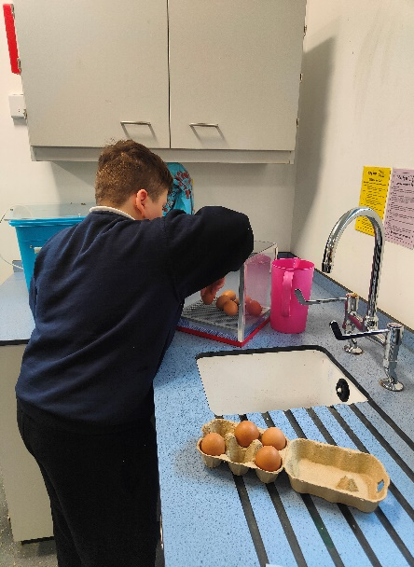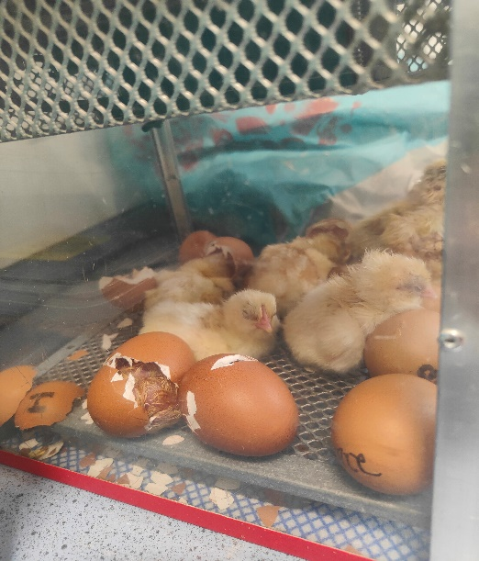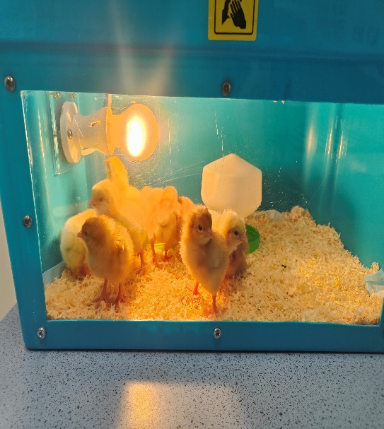
This term, we at Parkside House School have been fortunate enough to be involved in the Living Eggs hatching Programme. On day 1, we had 10 eggs delivered and the pupils were able to watch over them, eagerly anticipating the moment the chicks would hatch. Pupils learned all about how to prepare for them, set up the incubator, monitor the temperature, set up the brooder box, find suitable foods and generally how to care for the chicks. Pupils developed their knowledge of embryo development and were able to track what stage the embryos were up to each day. Pupils watched as all 10 chicks emerged from their eggs. Their excitement building as each and every tiny hole that was made in the shell, until the chicks wiggled out and were able to take their first wobbly steps. Pupils were then able to use their new skills to evaluate the chicks colouring to determine if they were hens or cockerels, we were fortunate to get 5 girls and 5 boys.
Everyone has had an amazing experience; it has been truly enriching for all pupils and staff at Parkside House School and we look forward to making this a regular Easter tradition!
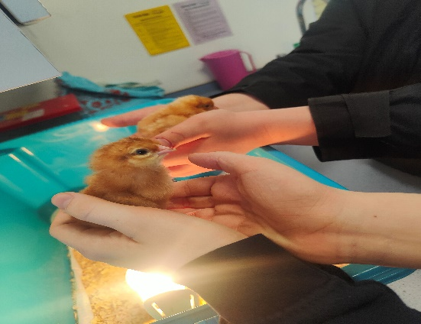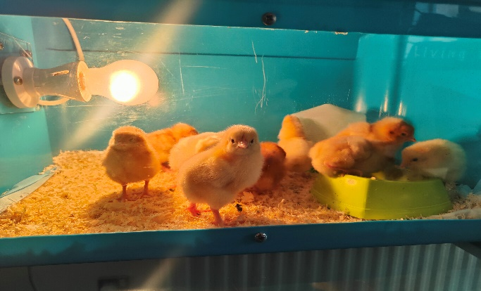

Mental Health Awareness Week 13th May – 17th May
This year’s Mental Health Awareness Week took place from Monday 13th – Friday 17th of May. The theme, as set by the Mental Health Foundation, was
“Movement: Moving for our mental health.
Many of the students and staff embraced this year’s theme and participated enthusiastically in ‘Mental Health Awareness’ week, joining in with many movement-based activities. Whilst several activities were arranged, some students also wrote their own daily activity plans including local walks, laps around our garden area and taking part in the obstacle activity. There was a definite impact highlighting the benefits of being active and socialising together to increase Mental Health Awareness
Even the dogs from the after school dog walking session loved being invoved… along with staff and the children!!!
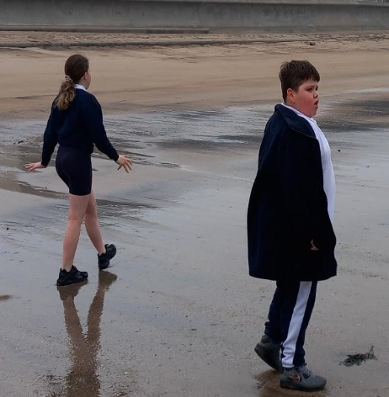
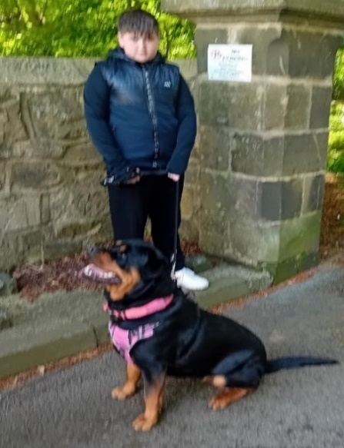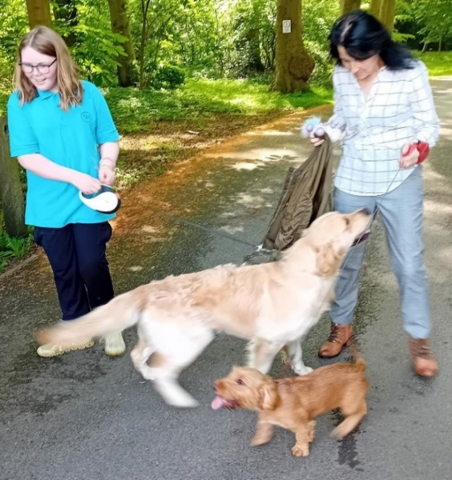 Even though the weather was a little cool that day, it wasn’t going to stop our beach walk. Staff and student still enjoyed being outside having a healthy stroll along the beach.
We all had great fun feeling more healthy and socialising at the dance drama class.
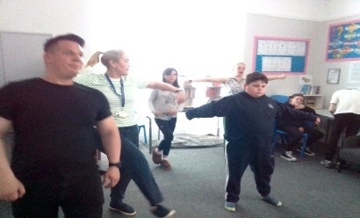
Environment Week 3rd June – 7th June
During the first week of June our staff and pupils came together to raise awareness and celebrate our local environment.
As a team we decided to:
EDUCATE ourselves and our communities about local environmental issues and look at how climate change will impact our region, the country, and the world.
PROMOTE values and behaviours that address environmental degradation and raise awareness of ways in which we can improve our routines to include more environmentally friendly options.
EMPOWER ourselves with the skills necessary to take action to help fight pollution and reduce climate change. Help everyone understand the value of recycling and re-using items. Raise awareness of the dangers of deforesting, water wastage and to look at ways to better protect our environment. And to increase understanding about energy usage and sustainability.
MAINTAIN new habits and remember that even the smallest actions can have a major impact.
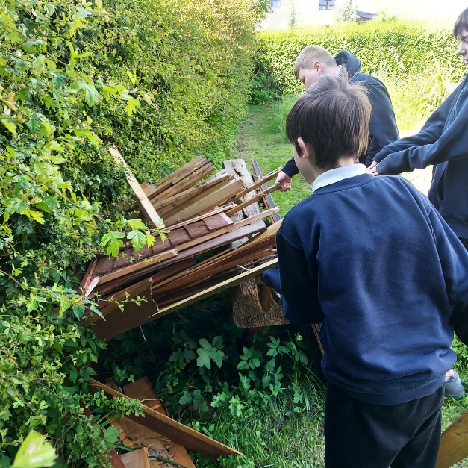
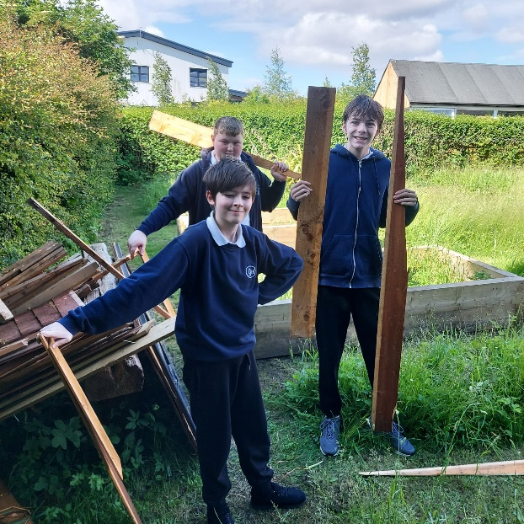
Recycling- Pupils sourced some materials, so that they may be reused to create new purposeful items. Pupils collected pieces of wood that was once used as a fence, took it back to the DT room and created wonderful items such as a money savings box and a guinea pig run.

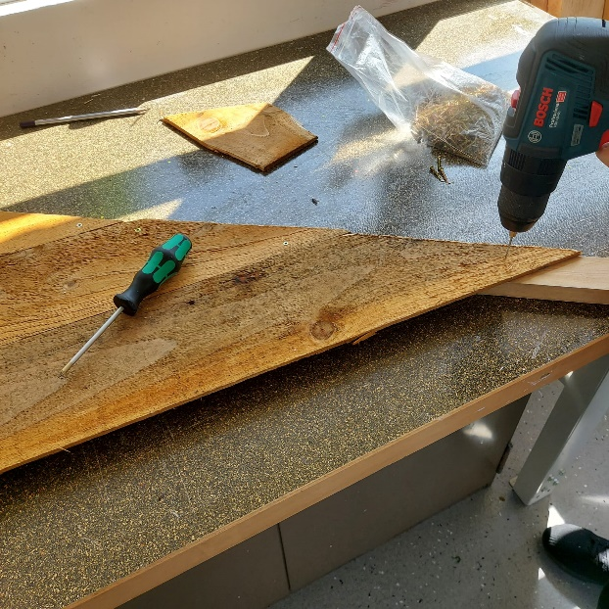
Environment Week Gallery
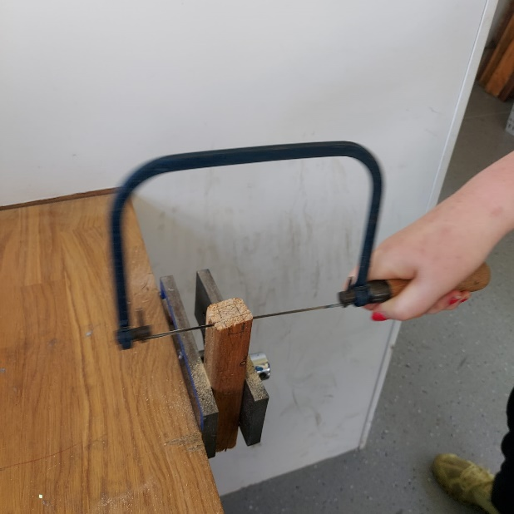

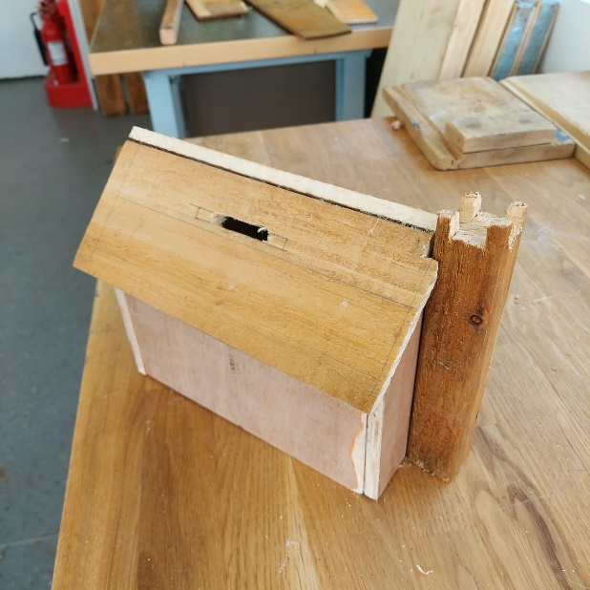
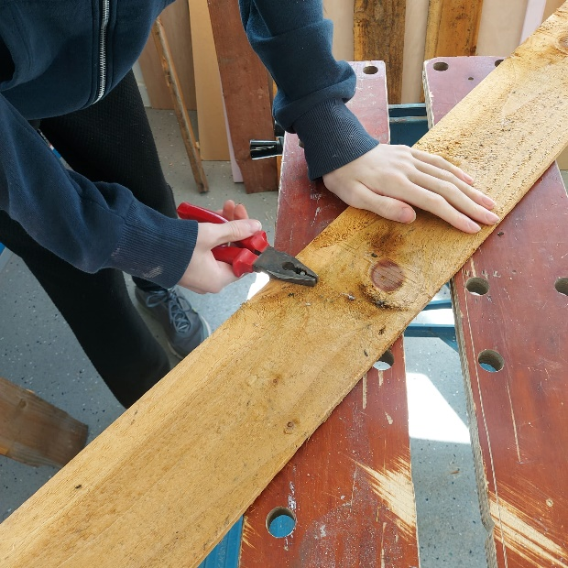

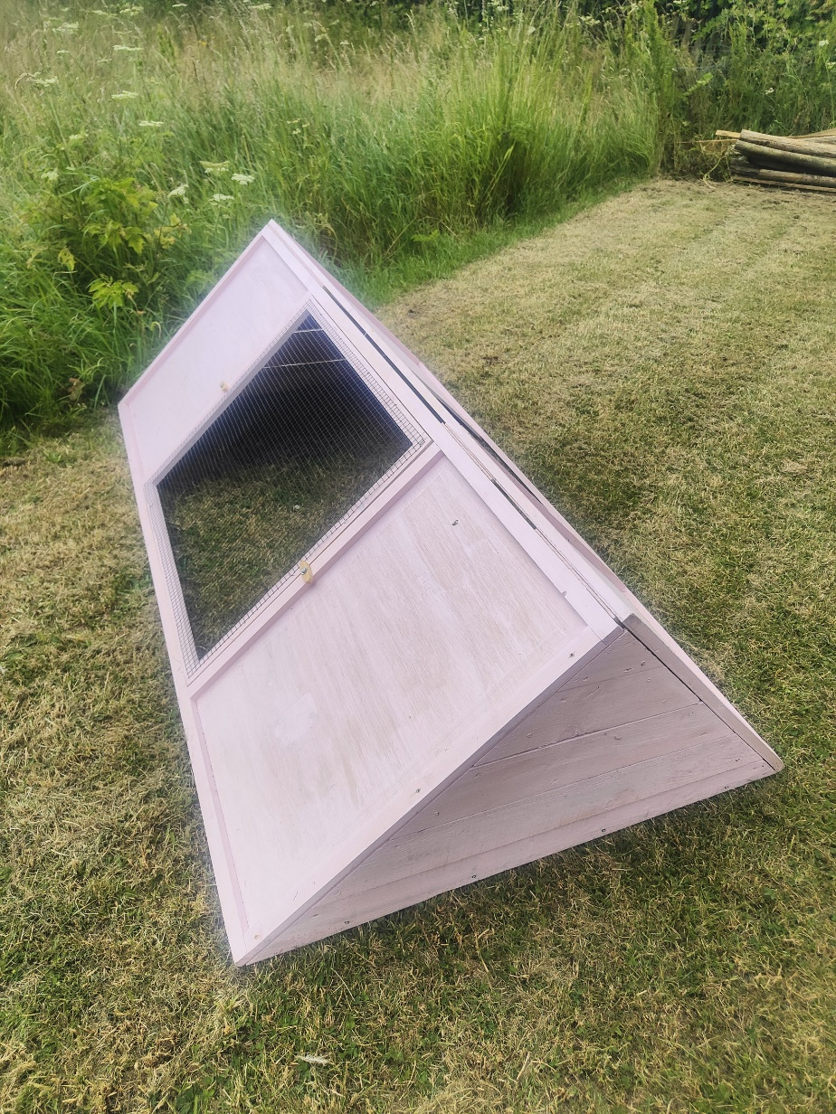

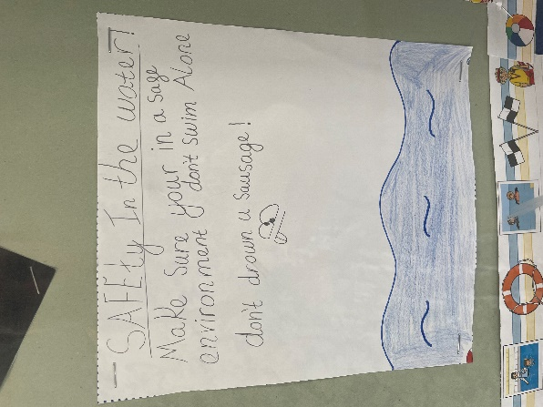
Water Safety Week 17th June – 21st June
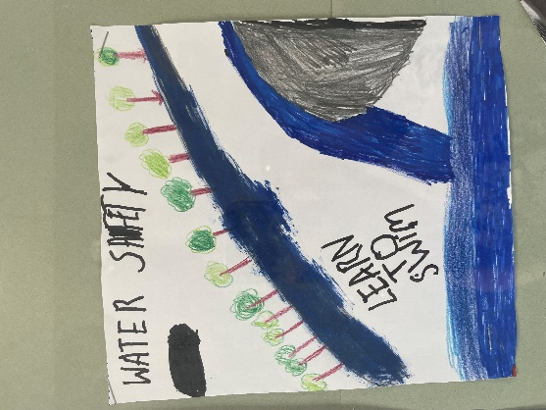
A tremendous success filled with engaging activities and invaluable learning experiences for our students. The week aimed to equip students with essential water safety knowledge and skills, ensuring they understand the importance of staying safe around water.

Some pupils were invited to swimming lessons, where students had the opportunity to improve their swimming skills under the guidance of our skilled instructors. The lessons focused on building confidence in the water, teaching essential swimming techniques and emphasizing safety protocols.

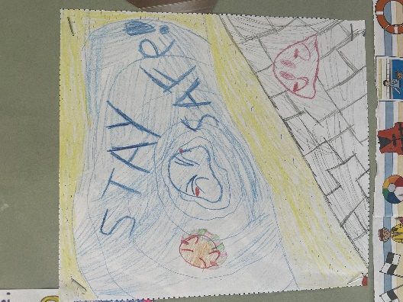
A highlight of the week was the RNLI (Royal National Lifeboat Institution) Water Safety Talk. A representative from the RNLI visited our school to educate students on water safety, the dangers of open water, and how to respond in an emergency. The session was interactive and informative, leaving students with a deeper understanding of how to stay safe near water.

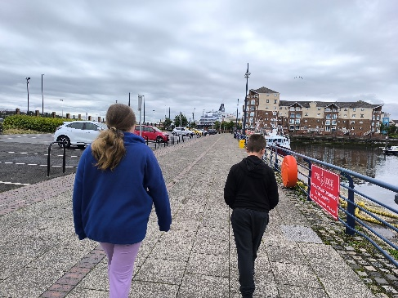
Midweek, students visited the local Fish Quay to learn about water safety signs. This hands-on experience allowed then to see real-world examples of safety signage, understand their meanings, and recognise the importance of adhering to these signs to prevent accidents.
Creativity flowed as students participated in a poster competition, illustrating key water safety messages. The competition encouraged students to think critically about water safety and express their understanding through art. The posters are now proudly displayed in school, serving as a constant reminder of the importance of water safety.
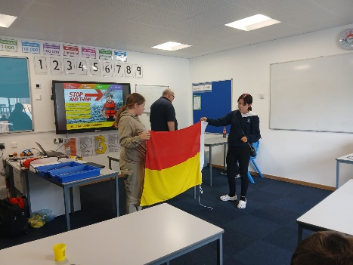
Year 8 students were treated to a special “Women in Engineering” lesson, focusing on the role of engineering in water safety. This inspiring session highlighted the contributions of female engineers in designing safety equipment and infrastructure, encouraging our students to consider careers in STEM fields.

To celebrate the culmination of Water Safety Week, students enjoyed a delightful lunch of fish and chips, followed by ice cream on Friday. This fun and delicious meal provided a perfect ending to a week of hard work and learning.

Ice Cream Van Visit
Pupils were rewarded for good behaviour with a visit from the Ice Cream Van, which was very well received on one of the few sunny days we have had this term. Pupils were rewarded for their good behaviour, and accommodating the photographer, whilst onsite taking photos around the school.

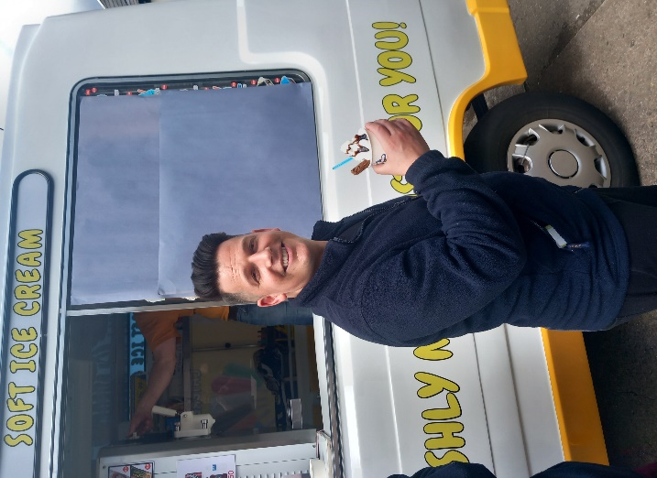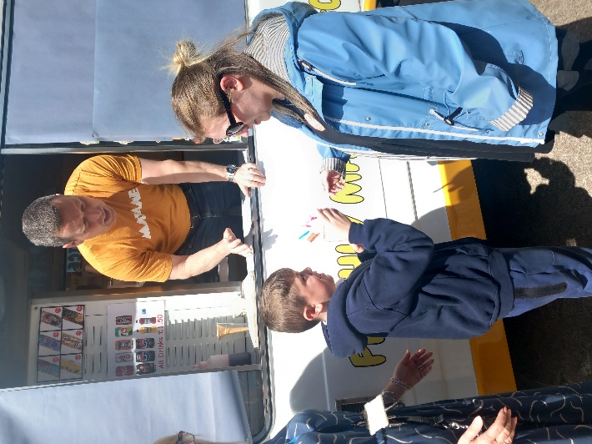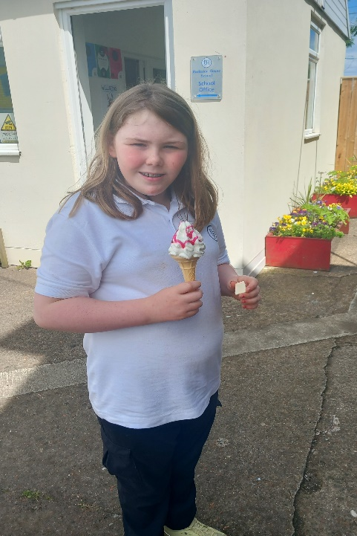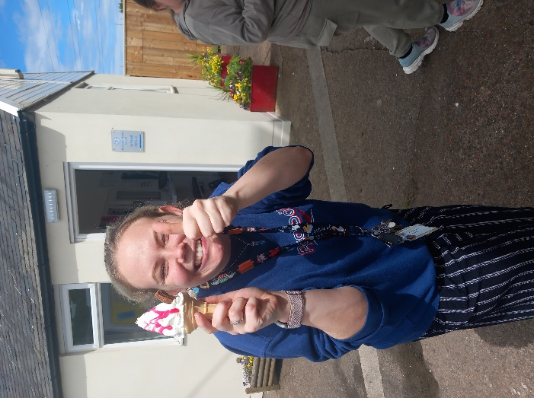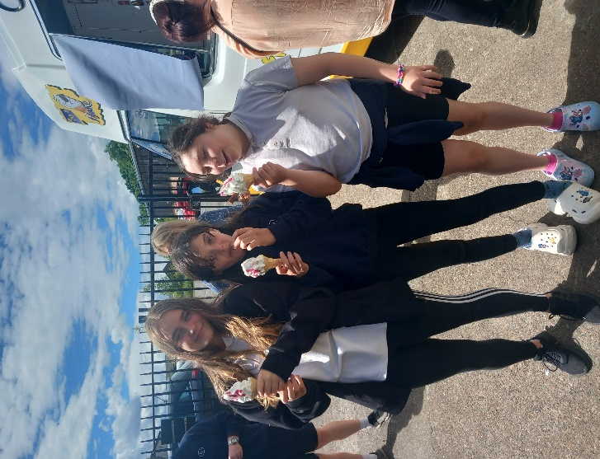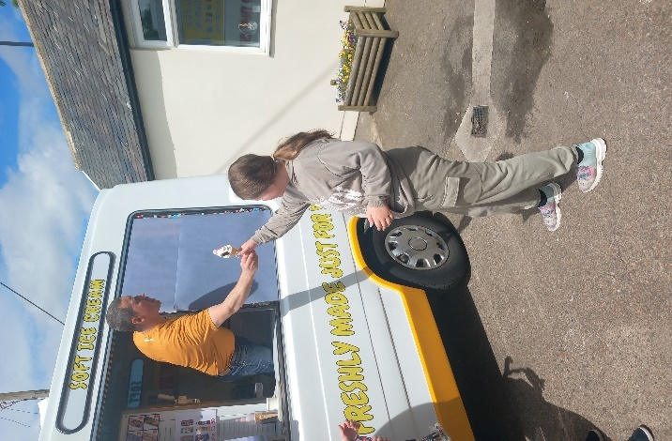

Enterprise Week 1st July – 5th July

We had an amazing start to the week with a visit to the cat and dog shelter at Longbenton for Enterprise Week. The first group went in the morning and enjoyed seeing the donkeys, asking questions about the dogs and engaged with the cats. The children had a real understanding of the safeguarding of animals. The second group attended in the afternoon and engaged well, despite the wet weather, they particularly enjoyed spending time with the cats. The children were asking so many questions to the staff at the cat and dog shelter. A lot of the children came away sad about the treatment of animals which helps when we talk about the ethics and morals of animal safety.
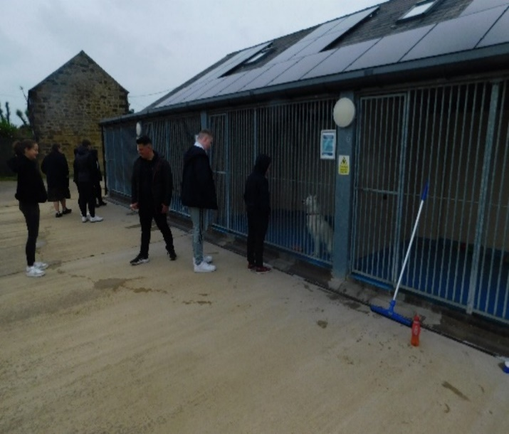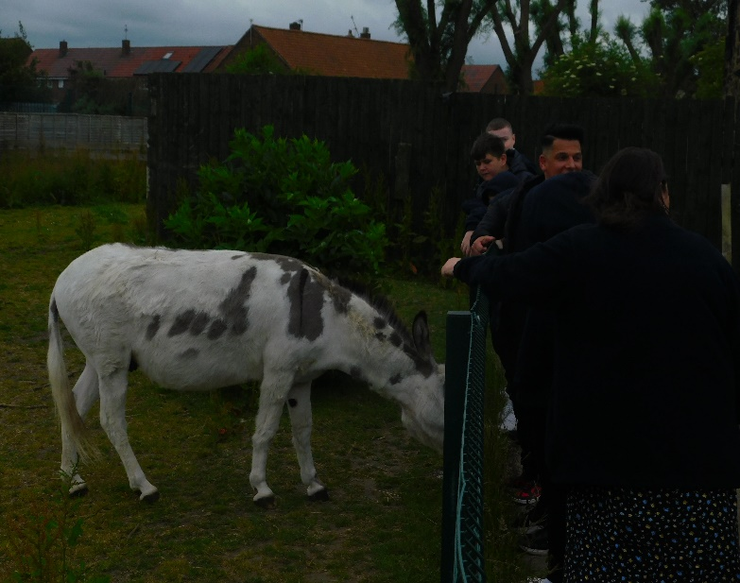

After the visit, the children were very passionate about making dog treats to raise money for the shelter throughout the week, to sell at the cake sale on Friday. All pupils really enjoyed making them. All children wore aprons, washed their hands and helped to tidy up afterwards. Children made posters about raising awareness about animal cruelty and promoting the cat and dog shelter. Whilst making the biscuits we spoke to the children about profits and how much they would like to raise for the cat and dog shelter while gaining a profit with the cost. We decided, as a team to make smaller bags for 50p and bigger bags for £1.
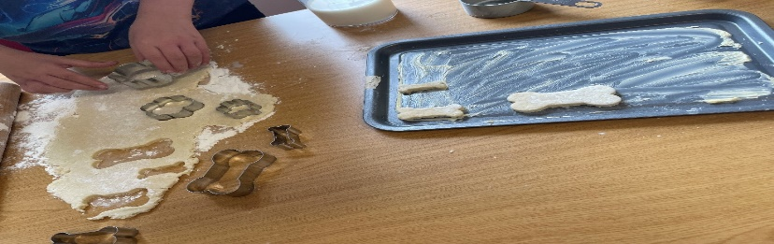

Friday we held a cake sale, selling the dog treats and other cakes donated by pupils and staff. Children handed in 51 WOW Vouchers which the children earned throughout the week for good behaviour, being kind and great work, and donated to the fund raising, which school will convert to cash to add to the total money raised. All children and staff seem to enjoy the week and fundraised a good amount of money to a good cause.

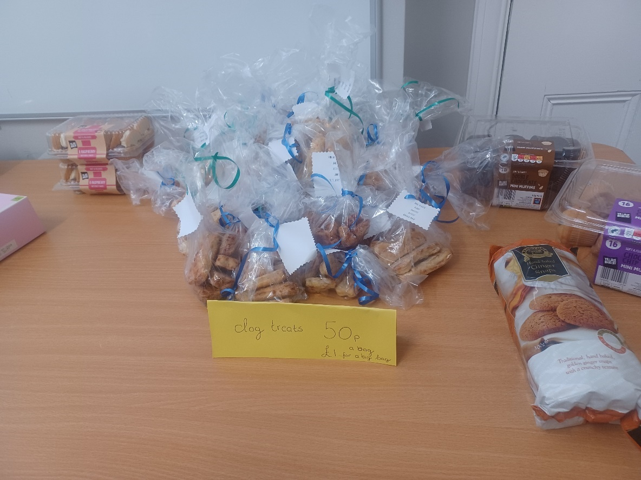
WE RAISED AN AMAZING £105 FOR THE CAT & DOG SHELTER!!

Election Day 4th July

Parkside held our very own Election Day.
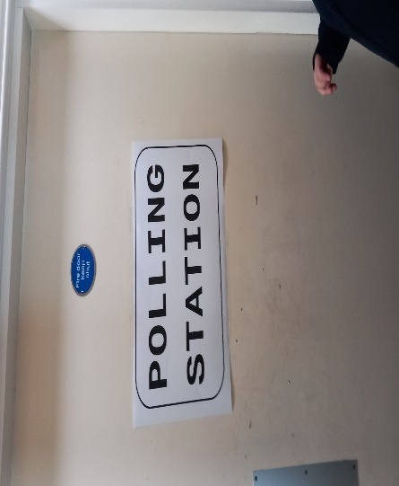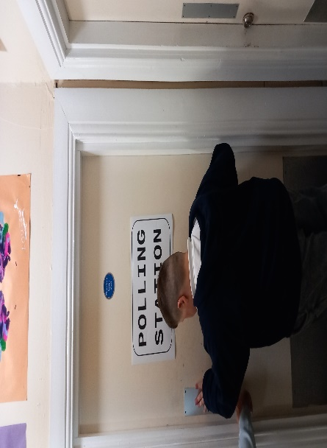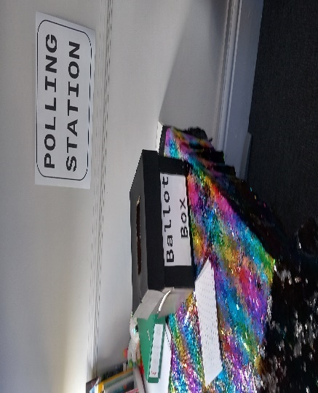And the votes are in……………

Leavers BBQ 11th July
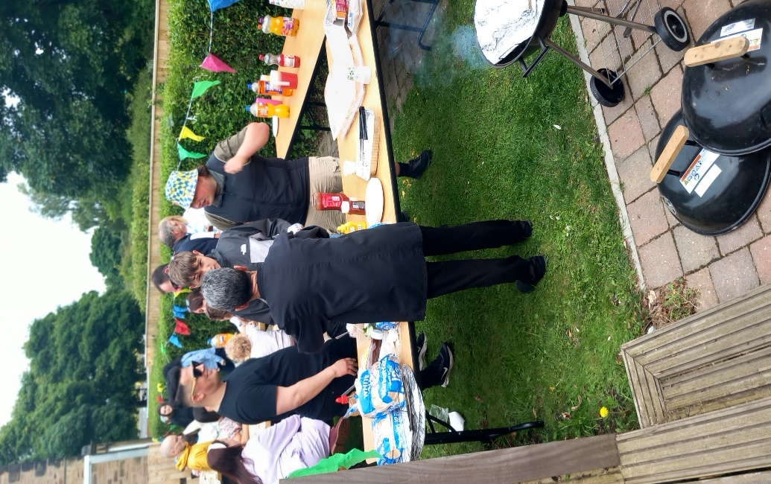
Thursday 11th July we were very thankful the rain stayed away to allow us to celebrate with our school leavers and held a BBQ in the grounds for our leavers.


Good Luck to all our leavers for the future, we are very proud of you all!

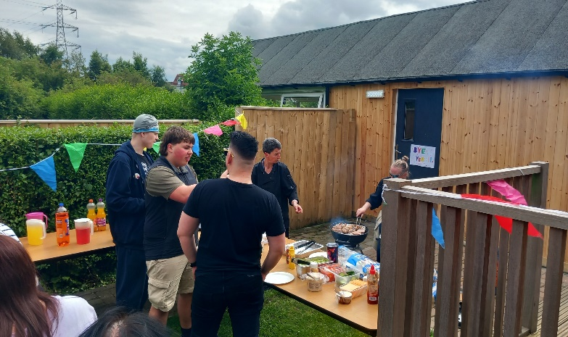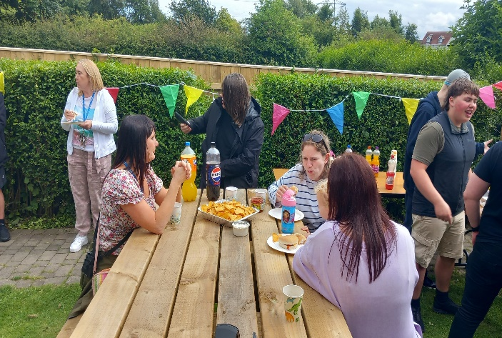

Sports Day 17th July

The First Annual Sports Day at Parkside House School
Parkside House School celebrated a momentous occasion with its first-ever Sports Day on July 16, 2024. The event, held in the school's garden area, was met with great enthusiasm from students and staff alike. The day was designed to promote physical fitness, teamwork, and school spirit, marking the beginning of a new tradition at Parkside.
The preparation for Sports Day began weeks in advance. A dedicated committee of staff led by Mr Turnbull, the PE teacher, worked to ensure every detail was covered. They organised a variety of events to cater to all age groups and interests, ranging from traditional track and field events to fun activities like sack races and tug-of-war. The school grounds were transformed into a vibrant arena ready for the students to channel their competitive side.
The day kicked off the entire school gathering on the main garden, where the students sat in their chosen teams for the first event to begin. Students choose their own teams to foster a sense of camaraderie and friendly competition. The events were varied to ensure inclusivity and maximum participation.
The events of the day were: Sack race, Egg & Soon race, Space Hopper race, Tug of War, Three- legged race, Penalty Shootout, Water balloon fight, Wet Sponge throw at staff, Whack-a-rat, Corn hole, and Coconut Shy.

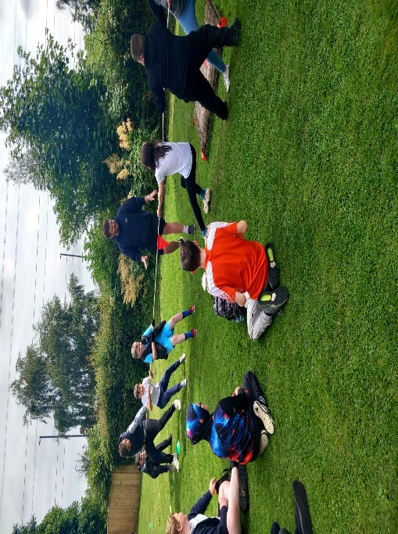
One of the most memorable moments was the tug of war competition, which had students cheering wildly for their peers and teachers. The enthusiasm was infectious, with staff joining in the fun and games.

Another highlight of the day was the wet sponge throw (which received a large amount of interest from the students) with Mr Turnbull (in fancy dress), Mrs Young and Mrs Goldborough being splattered continuously with wet sponges.

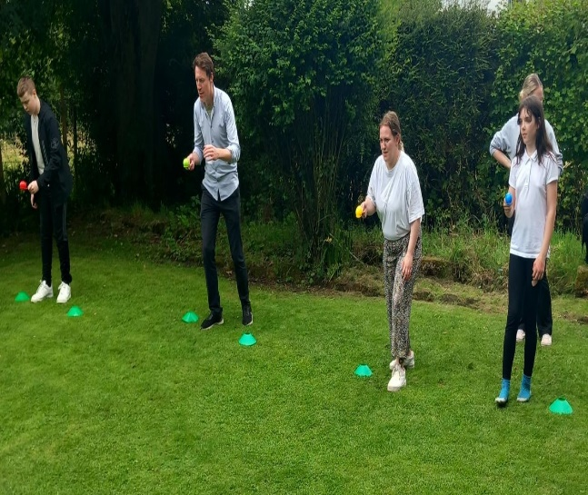
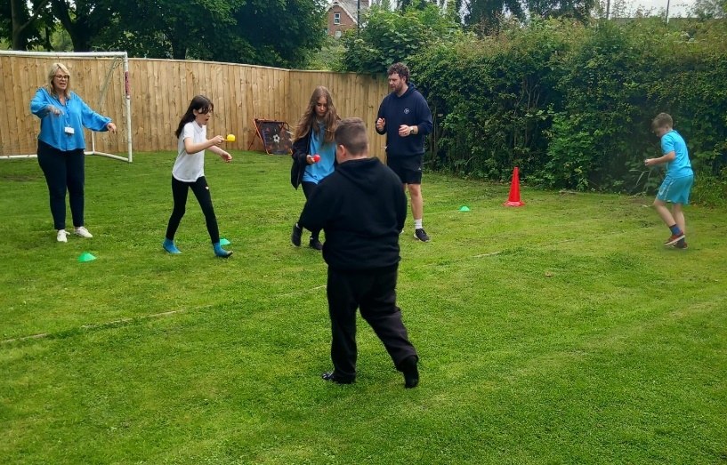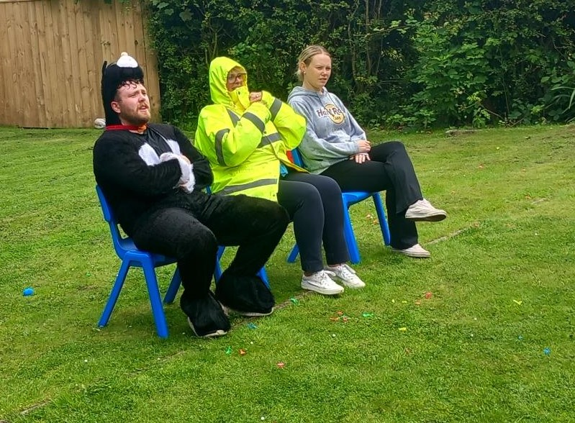
The day ended with the award ceremony, where students received medals and trophies for their outstanding performances, sportsmanship, and team spirit.
The first Sports Day at Parkside House School was a resounding success, bringing the school community together in a celebration of athleticism, teamwork, and fun. It was a day filled with joy, laughter, and unforgettable moments. The positive feedback from students and staff has set a strong foundation for making Sports Day an annual tradition at Parkside. The event not only highlighted the importance of physical activity but also fostered a sense of unity and pride within the school community.
As the day came to a close, there was a unanimous agreement that Sports Day had become an integral part of Parkside House Schools culture, leaving everyone eagerly anticipating next year’s event.

Sports Day Gallery
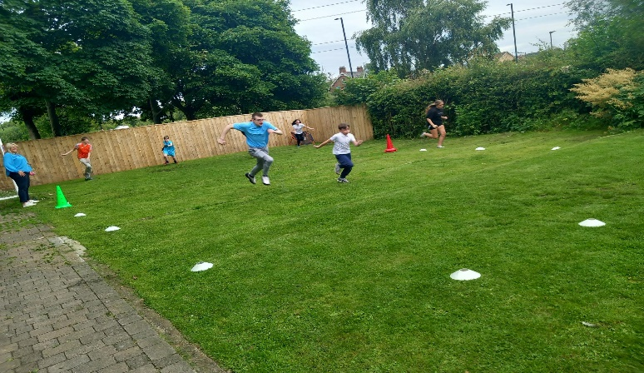
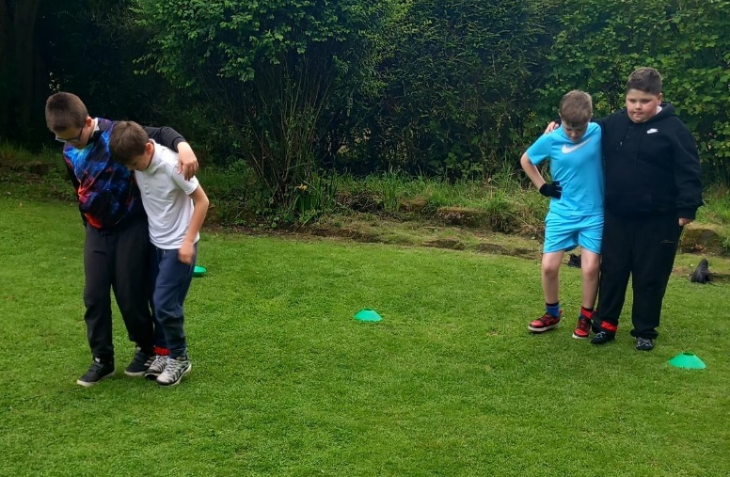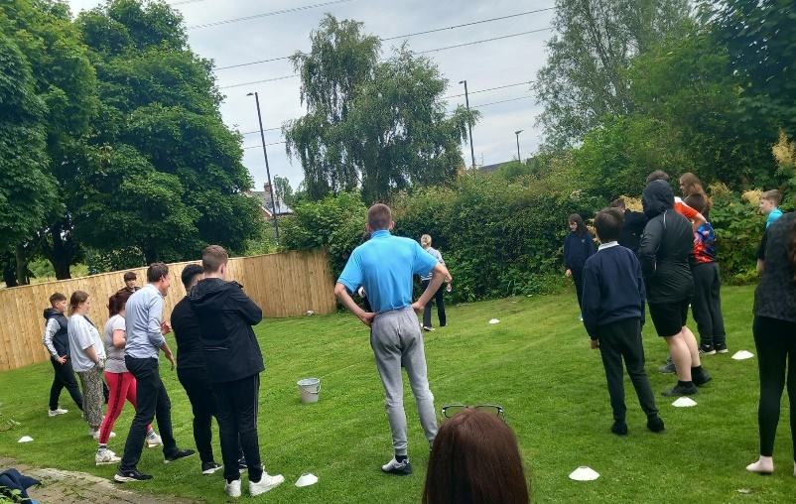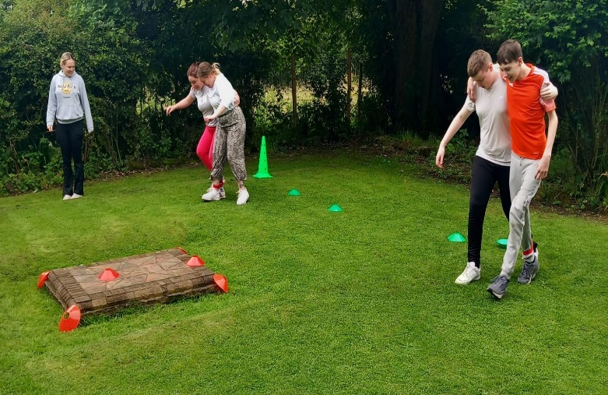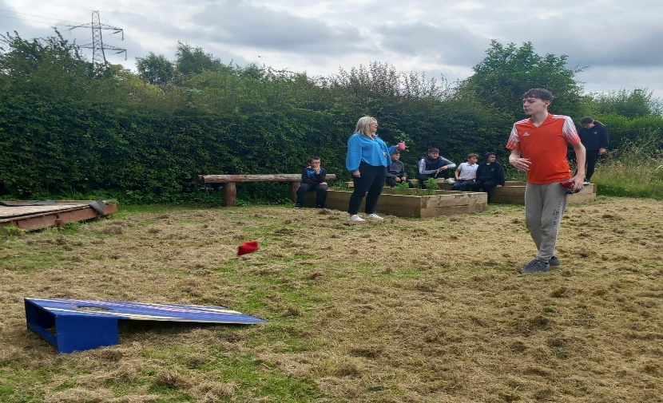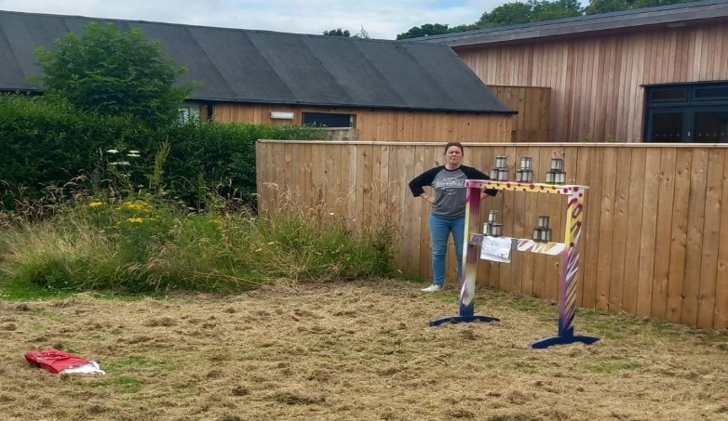

Well Being Award 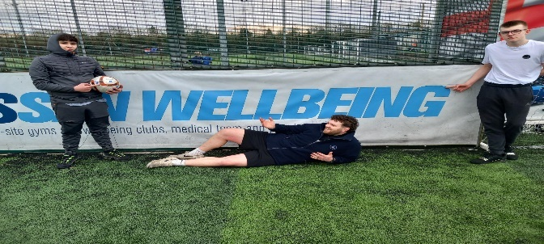

The Wellbeing Page is now up and running on our website. It contains lots of important information about mental health and wellbeing with support, including links to various helpful information.
Our Wellbeing Team which is made up of students, teachers, and parents, are currently working on creating our Vision Statement so this will be a combined effort and input from all parties. The team will be planning to implement various new strategies from September to ensure wellbeing is a priority for all students, staff and parents.

Parkside will provide parents with various information around mental health and wellbeing to ensure they are aware of the signs and symptoms, whether that is in a friend, their child or themselves to be able to correctly provide support.



END OF TERM AWARDS

Highest Credit Earner

Ruby Slater

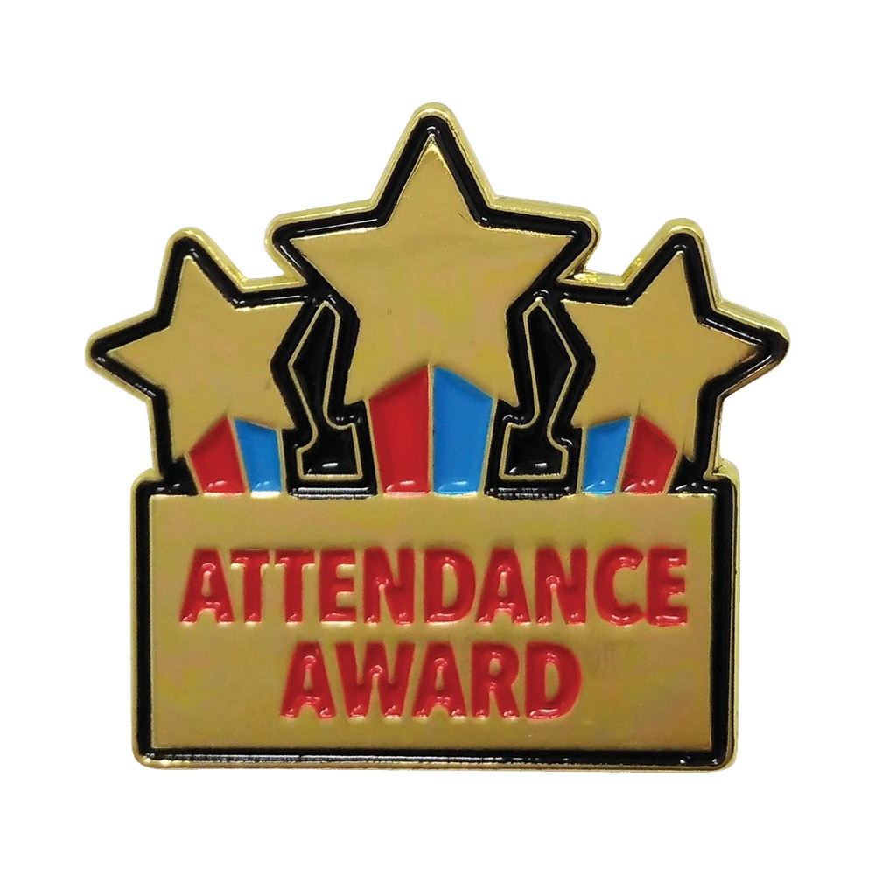
100%
D Atkinson D L Adams
L Butler L Rutherford R Slater
A Yearnshire JaYearnshire JoYearnshire
Gold
L Campbell D Clark Mason L Strain D Walker
Silver
E Bloomfield A Lawson A McAuley L McKeith K Storey C Taylor
A Thompson

Helping Hands Award

Ari McAuley

Sports Person of The Year Award

Leon Strain & Jermaine Mcalle

Most Improved Attendance
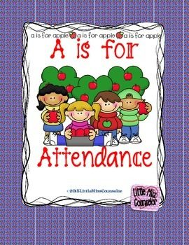
Lilly Gormley

Lilly Gormley
Pupil’s Who have Made the most progress of the Year

Ami-Leigh Thompson & Callum Hill
Most Progress Made In Summer Term
Leon McKeith


Most Improved Sports Person Award

Danny Walker
Pupil Of the Year

Dean Atkinson
Most Improved Reader Award

Bailey Ross & Chloe Taylor Walker
Offsite Learning Award
Summer Finnerty

Term & Holiday Dates School Year 2024 – 2025
Holiday | School Will Close | Pupils Return To School
Autumn Term starts Tuesday 3rd September 2024
Autumn Term |  | Tuesday 3rd September 2024
Autumn Half Term | Friday 25th October 2024 | Tuesday 5th November 2024
Christmas Holiday 2024 | Friday 20th December 2024 | Wednesday 8th January 2025
Spring Term Starts Wednesday 8th January 2025
Spring Half Term 2025 | Friday 21st February 2025 | Monday 3rd March 2025
Easter Holidays 2025 | Friday 11th April 2025 | Monday 28th April 2025
Summer Term starts Monday 28th April 2025
Bank Holiday | Monday 5th May 2025 | Tuesday 6th May 2025
Summer Half Term 2025 | Friday 23rd May 2025 | Monday 2nd June 2025
Summer Term End | Friday 18th July 2025 | Monday 1st September 2025

Teacher Training Days – All Staff available for consultation
Monday 2nd September 2024
Monday 4th November 2024
Monday 6th January 2025
Tuesday 7th January 2025 ***School to confirm further 1 training day throughout the school year**



