Meet your Occupational Therapist…
Hello!
I’m Tracey. I am really looking forward to hearing about you, your future plans and what you want to achieve!

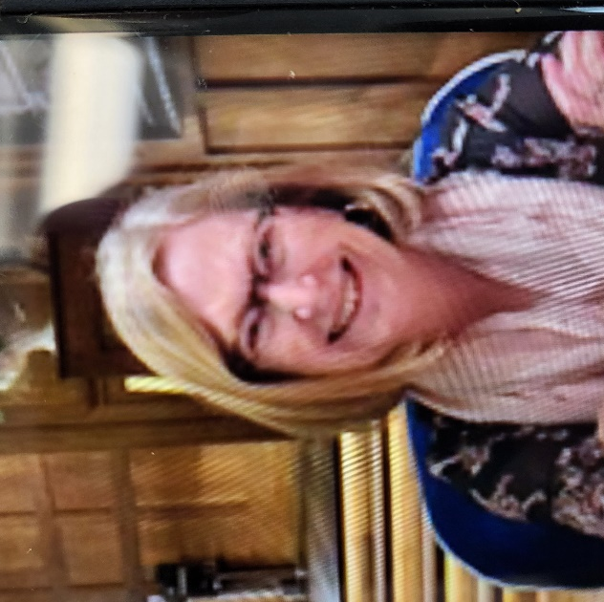

Getting to know Tracey…

- I enjoy listening to music
- My favourite colour is Aqua
- I have lived in Australia for a while
- My football team is Liverpool FC but starting to enjoy watching Newcastle United as well!
- I enjoy watching documentaries.
- I enjoy walking, Zumba and going to Yoga
- My friends and family are important to me.
- I like to be around people and have fun.

What is Tracey’s role?

The role of an Occupational Therapist is varied but
ultimately, I will be supporting you with
your next steps and helping you to achieve your goals
and ambitions. I will look at occupations that are
important to you and help you to participate in these.

You may see me in 1:1 sessions, groups, in the
classroom, during activities or perhaps at home
depending on your needs and what works best for
you!

Occupational Therapy is all about you!

Reasons why you may see Tracey

If you are struggling to do something then you may come and see me for support. This could be struggling with independence skills, learning at school or at home or accessing your favourite activities. It may be that you are unable to do this physically or that you find it difficult to remain focused.

More Information about Occupational Therapy

What is Occupational Therapy?

An Occupational Therapist is training to support people to participate in every day life which also supports their health and wellbeing. Every day, you will take part in multiple occupations – from the moment that you wake up, to when you go to sleep (an occupation is not just a job!) Examples of occupations can be self care such as getting yourself washed and dressed, going to school and leisure activities that you enjoy.

Within the school environment, you may see me individually, within a group or whilst you are doing a specific activity, within the classroom or even at home! My job is to provide reassurance and advice but also to help you to achieve your goals!

You may see me regularly, or just once in a while! It is all about what works best for you and how you want to be supported to achieve.

What will we do in an Occupational Therapy Session?

It is really important that I find out all about you! So I will meet with you and find out what you may be struggling with, what you want help with, your goals and your aspirations. I will see you in the classroom environment and speak to the people that know you best both at home and school as well.
Our sessions are always unique and I try to make them as fun as possible. We may complete some assessments but it is just to help me find out what you good at! We may play games, talk, draw or something different. Group activities can include playing games or focusing on your next steps.

Which areas might an Occupational Therapist work on?

- Movement and physical development to enable engagement in activities
- Sensory needs
- Organisation skills to support independence
- Independence skills
- Transition to college or next steps

